FS300A Flow sensor
Product features:
- Appearance of the productLightweight flexible,Small volume,Convenient installation.
- inside impellerset Stainless steel bead,forever wear-resisting.
- Seal ring using Up and down Structure of force never leaking.
- Hall element using German imports,and using The isolation design
To prevent water,never aging.
- All raw materials Comply with ROHS testing standard
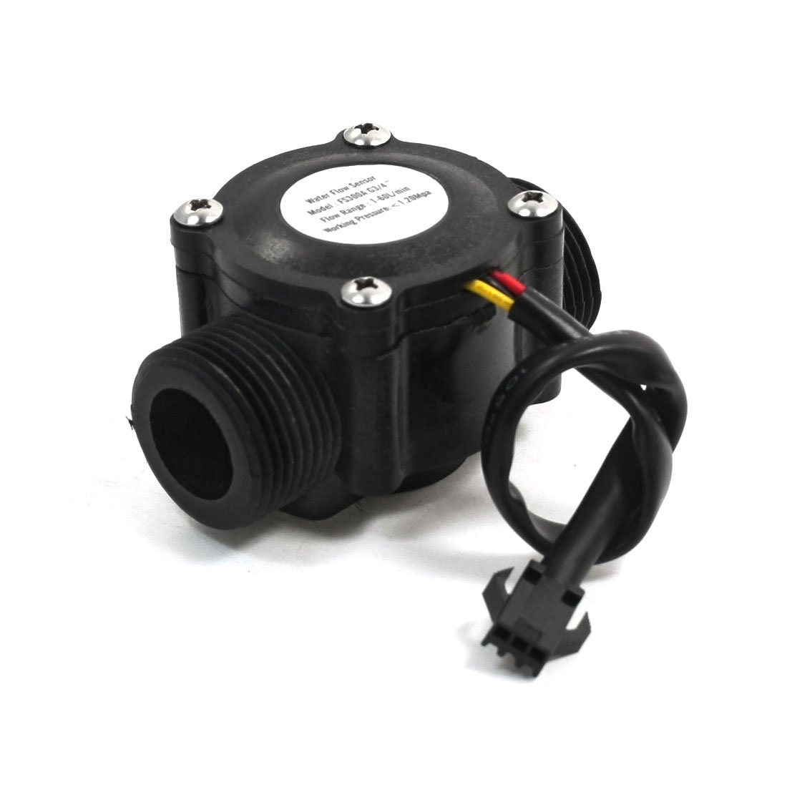

一、Product introduction：
The water flow sensor is mainly composed of plastic valve body, water flow rotor component and hall sensor.It is installed in the water heater inlet, used to detect water flow, when the water through flow rotor components, magnetic rotor rotation and speed changes with the flow, hall sensor output pulse signal, feedback to the controller, the controller to judge the size of the water flow, adjust and control.
- Matters needing attention
- Severe shock and chemical erosion are strictly prohibited.。
- It is strictly prohibited to throw or collide。 安装方向示意图
- Strictly follow the product to the water direction, connect the water pipe。 OUT
- Liquid temperature should not exceed 120 C。

三Output waveform diagram： IN

Duty Cy=40%～60%

四、 Connection mode：

red IN

Hall element
JST

yellow OUT
JST

black GND
JST

五、技术参数

Scope of application: |  | 适用于全自动燃气热水器
The basic parameters | 1、Minimum rated working voltage | DC 5V-24V
The basic parameters | 2、Maximum working current | 15 mA （DC 5V）
The basic parameters | 3、Maximum working current | DC 5～18 V
The basic parameters | 4、Load capacity | ≤10 mA （DC 5V）
The basic parameters | 5、Temperature range | ≤80℃
The basic parameters | 6、Temperature range | 35%～90%RH（No Frosting state）
The basic parameters | 7、Allow the pressure | hydraulic pressure 1.75Mpa below
The basic parameters | 8、Keep the temperature | -25～+80℃
The basic parameters | 9、Save the humidity | 25%～95%RH
Technical requirements | 1、The output pulse is high | >DC 4.5 V (Input voltage DC 5 V)
Technical requirements | 2、The output pulse is low | <DC 0.5 V (Input voltage DC 5 V)
Technical requirements | 3、accuracy  （Flow rate--Pulse output） | 0.5～60 L/min±5%
Technical requirements | 4、The output pulse Duty ratio | 50±10%
Technical requirements | 5、output Rise time | 0.04μS
Technical requirements | 6、output Fall time | 0.18μS
Technical requirements | 7、Flow rate-Pulse characteristics | Horizontal test pulse frequency (Hz)= [5.5 * Q] + + / -3% (level test) (Q is flow L/min)
Technical requirements | 8、Impact resistance | The product packaging is good, from 50cm height X, Y and Z free fall to the concrete surface without exception,  Within 5% of accuracy change.
Technical requirements | 9、Insulation resistance | Hall sensor and insulation resistance between copper body above 100 m Ω.(DC 500 v)
Technical requirements | 10、 Heat resistance | In the 80 + 3 ℃ environment for 48 h, return to room temperature for 1 to 2 h without exception, no crack, relaxation and parts, expansion and deformation phenomenon, change within 10% accuracy.
Technical requirements | 11、Cold resistance | In the - 20 + / - 3 ℃ environment for 48 h, return to room temperature for 1 to 2 h without exception, no crack, relaxation and parts, expansion and deformation phenomenon, change within 10% accuracy.
Technical requirements | 12、Humidity resistance | In 40 + 2 ℃, relative humidity 90% ~ 95% RH environment put out 72 h after more than 1 m Ω insulation resistance.
Technical requirements | 13、Tensile strength | The tension of 1 minute 10N is applied on the derivation line, no looseness and dissonation, and no change in performance.
Technical requirements | 14、Durability | At normal temperature, the water pressure of 0.1MPa from the intake inlet is connected to the 1S, and the 0.5S is disconnected.  The test was no abnormal for 300,000 times.

